Welcome to Ms. Sacra’s Health Class (in the Wellness department)
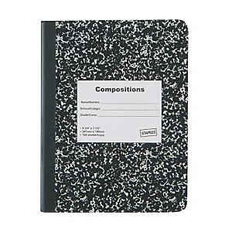
This year we will be discussing many health topics that will give your child the knowledge to make the most educated decisions necessary to live a healthy lifestyle. I’m super excited to start an amazing year with these chickadees!
I asked students to get a journal for the class so that all notes can be kept in the class as well as give the students opportunities to reflect on certain subjects. I highly recommend getting a two pocket folder with paper to write in. All tests will be open note and this way their materials will be all in one place.
Class will run the following way:
- DO NOW to get our minds right into the topics of the day
- Core components of the class – the main points I want them to take away from class
- Activity or class discussion surrounding the specific core topics
- Conclusion – why is what we just learned important and relevant in your life?
Grading will be made up of:
- 2 points every day for participation for a total average of 50 pts. Per term.
- In school classwork – some classwork like group work, worksheets, or activities will be graded and I will tell you well in advance if this will count to your grade.
- Any addition points are coming from Initiative Assessments – assignments/tests given in class to take the material one step more and impact our thought process.
Reward system – I do something called “Thumbs-up Awards” for doing something above and beyond in the classroom. When a student gets 5 ‘thumbs-up awards’ it turns into a high-five award which means a special treat from me!
My website with all the information can be found on my Edline page or simple go to sacrahealth.weeble.com
I will be available any morning before school if they need anything.
If you need to reach me, these are the best ways:
Email: bsacra@slrsd.org
Phone: 781-582-3555 ext. 3365

